The exact address of the studio is Beco das Flores, number 17, where the pin "A" stands. (The Yellow Studio is on the 1ST floor left; and the Red Studio on the 2nd floor left.) Here's the Googlemap of the studio's surroundings (the Castle, Chiado, Baixa/Rossio, Mouraria, Martim Moniz): https://goo.gl/maps/O6L27
(The view from the windows of the studio is towards another street, called Rua da Achada)
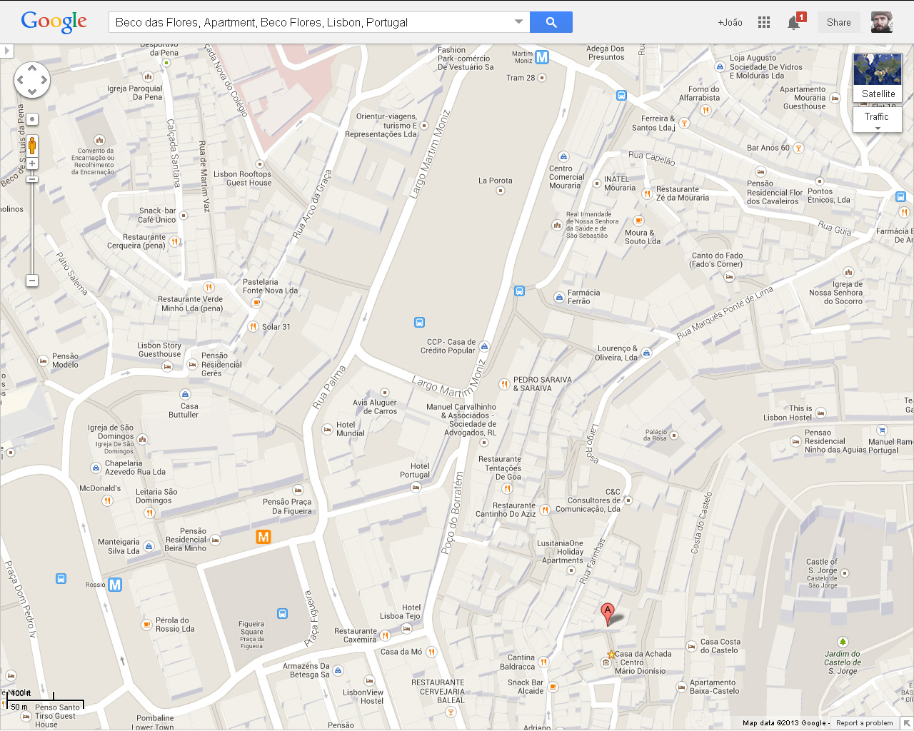
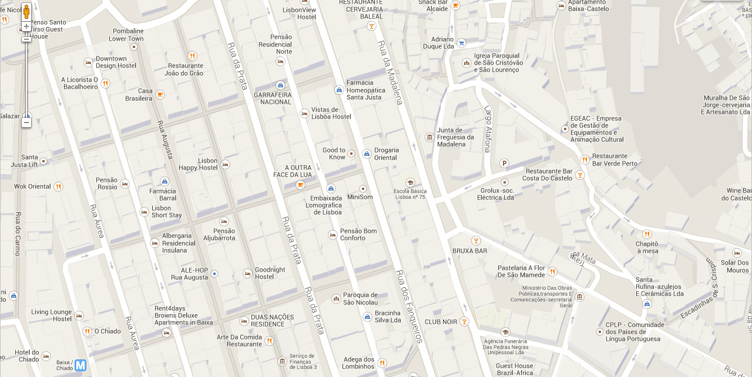

MARTIM MONIZ SQUARE

TRAIN STATION
TO SINTRA

CASTELO DE SÃO JORGE

PRAÇA DA FIGUEIRA
(THE ROSSIO METRO STATION HAS AN
EXIT THAT LEADS TO THIS SQUARE)
ROSSIO SQUARE

BECO DAS FLORES

LARGO
DA ACHADA

BAIXA

CHIADO

TRAIN STATION SANTA APOLÓNIA
RIO TEJO/
RIVER TAGUS

And here's a map connecting the Santa Apolónia train station to the Studio:
https://goo.gl/maps/aVVXa

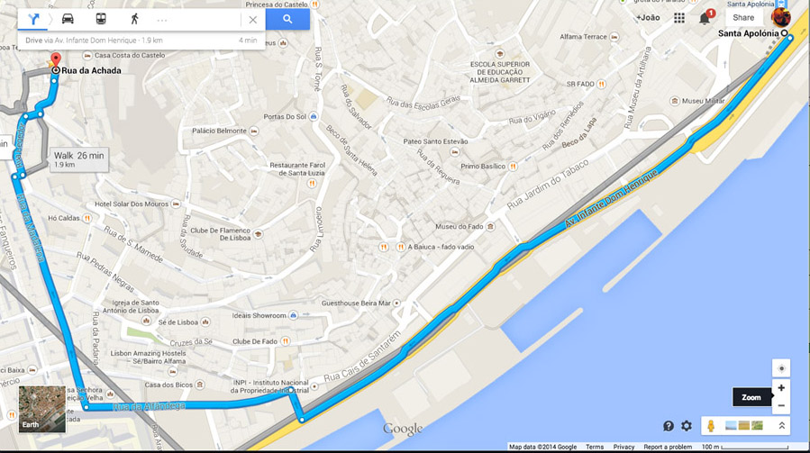

GETTING THERE FROM THE TRAIN STATION

The closest train station to the studio is called Santa Apolónia. Most trains that come to Lisbon end up there. (Occasionally, some trains have as their last stop the previous station, further East, called Oriente. If that's the case, then you should catch another train towards Santa Apolónia, it's another 5 or 10 minutes, and, supposedly, your ticket is also valid for that short trip.)

By FOOT: The blue line drawn in the map shows you the easiest way to get to the studio. It's a 20-25 minute walk from Santa Apolónia to Beco das Flores/ Rua da Achada.

By BUS: There are many bus options next to the train station. Bus 759 should be the best option, but most other buses there can also drop you off closer to the main squares in downtown, then it's a 5-10 min walk. Take the bus towards West!

By METRO: Take the metro's blue line (linha azul) from Santa Apolónia till Rossio, then it's a 10 min walk. It should cost around 2,00€ each person. The ticket that you purchase at the station is rechargeable and thus reusable in both metro or bus. In Rossio station choose the “Praça da Figueira” exit. And then from there you can follow the map on the first page of this document.

By TAXI: The blue line in the map shows you the way a taxi should take. It's a 5 minute ride from the Santa Apolónia train station to Beco das Flores. I think will cost under 8 euros at the most (plus the additional fee of 1,60€ that they charge if some large size luggage has to go in the trunk). It might be less, cause it's not far, I'm just supposing that there might be traffic. Tell the taxi driver you want to drop off at Rua das Farinhas number 7. Then Beco das Flores is the little street with stairs just in front of that door. VERY IMPORTANT: Make sure that the taxi driver turns the taximeter on as soon as you enter the taxi. If he doesn’t, then ask him to do it. If he still doesn’t, choose another taxi.

If you don’t like maps and prefer to ask directions: from Rossio or from anywhere downtown, you just have to ask for Rua da Madalena, then start asking directions on how to get to Largo da Achada, and then from there ask where Beco das Flores is.

Mouraria is a steep hill between downtown and the castle and to get to the studio you have to go up quite a few stairs. So, if you’re carrying heavy luggage and you want to avoid the stairs, you should use the public lift nearby (Elevador do Castelo - green star in the map).

You can see the house if you stand at the highest point of Largo da Achada and look North. It's a white house with bordeaux doors and windows, right next to a yellowish Cultural Centre called Casa da Achada. Take a look at the first map.

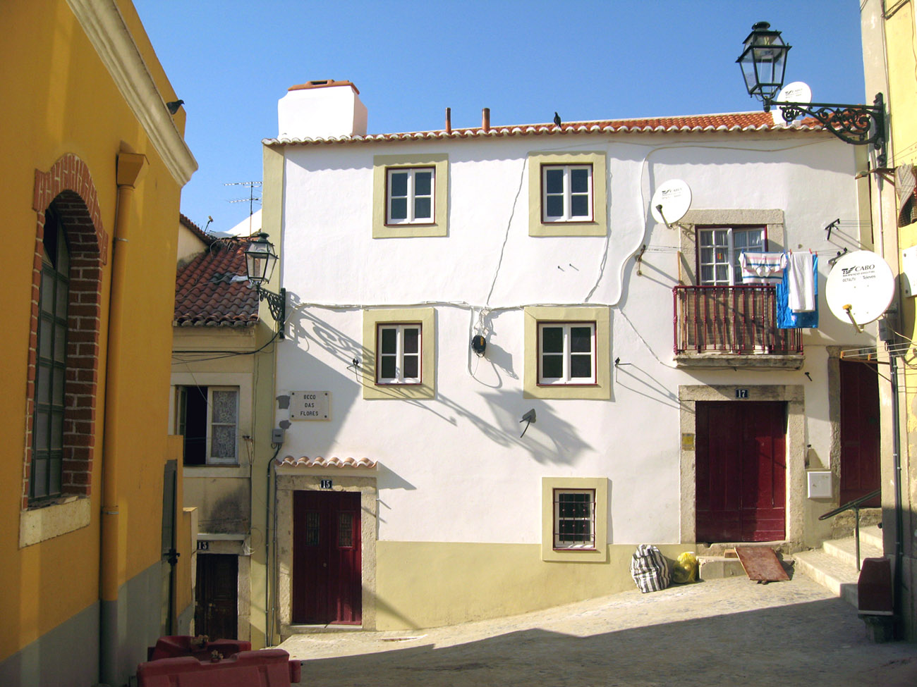
Yellow
Studio
Red Studio

In case you get lost, text or call me at (+351) 966 064 313!
In alternative, my parents’ numbers are (+351) 965 870 694 and (+351) 963 063 777

João

